Year 8 STATISTICS PRACTICE TEST
Name:

Date:

QUESTION 1
Calculate the mean, median, mode and range for the following set of data. Show ALL of your working out in the boxes below.
23, 32, 16, 37, 15, 31, 25, 21
Mean:

Median:

Mode:

Range:

QUESTION 2
For the following two questions, you need to firstly state whether a mistake in the calculations has been made and secondly correct the mistake in the space in the box below.
- Find the median:  4, 12, 1, 7, 3, 4, 1  Median = 3.5 | Is there a mistake? YES/NO  CORRECT THE MISTAKE IN THE ANSWER...
- Find the range:  104, 22, 97, 43, 31  Range = 75 | Is there a mistake? YES/NO  CORRECT THE MISTAKE IN THE ANSWER...

QUESTION 3
Use only the numbered cards below to answer the following question.
4
6
3
7
4
5
1
9
Choose 3 numbers from the cards above which satisfy the following:
- mode of 4 AND a range of 2

QUESTION 4
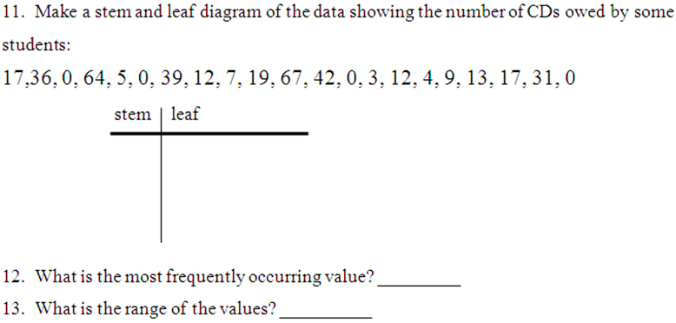

QUESTION 5
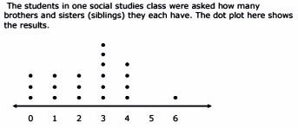
- How many students were surveyed?
- What is the mode number of siblings?
- What is the median number of siblings?

QUESTION 6
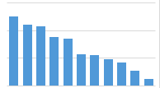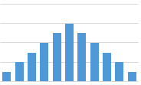
This data set is ___________ skewed This data set is ________________

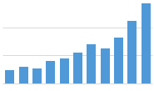 This data set is ___________ skewed

QUESTION 7
The times taken by 24 students to complete a mathematical puzzle are shown below in minutes:
5, 22, 8, 13, 7, 9, 6, 8, 12, 10, 4, 9, 3,19, 18, 9, 14, 2, 5, 15, 21, 11, 5, 17

Construct a grouped frequency table for the data above using the following groups:
0–4, 5–9, 10–14, 15–19 and 20–24
Time taken (minutes) | Tally | Frequency
(2 marks)
(b.) Now construct a histogram on the grid below using this information. Make sure to label your histogram properly.
(4 marks)

